**4.6 Graphs of Other Trigonometric Function**

**Objective: Sketch graphs of tangent, cotangent, secant, cosecant functions**

Remember, we touched on this first semester… we watched a youtube video that corresponds the sine and cosine graph to the points on the unit circle…

Image of tangent function (Tangent) **y = tan x**

Remember tan is sin/cos so tan can NOT exist when cos x = 0

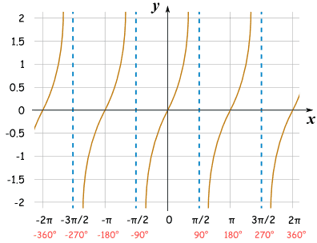

Image of cotangent function (Cotangent) **y = cot x**

Remember tan is cos/sin so tan can NOT exist when sin x = 0

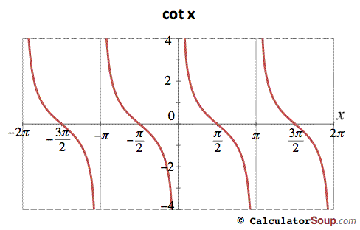

Image of reciprocal function (Cosecant) **y = csc x = 1/sin x**

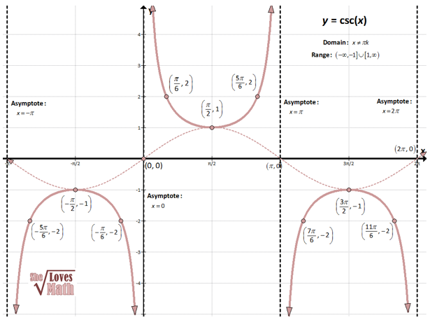

Image of reciprocal function (Secant) **y = sec x = 1/cos x**

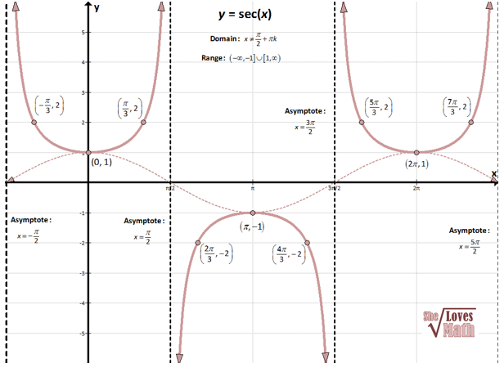

Have a discussion about how the key points come from the sine and cosine function graphs, relative to those same points on the unit circle.

**Homework** Pg 337 #15, 17, 19, 25, 31, 35